Feedback 24/05/24 – 30 minute call -
Web Automation
BDD – too granular not step level like what I’ve done. Thhen complete checkout checkout process.
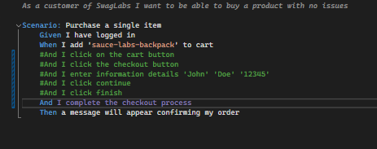
Two steps – must have a When and Then . WHEN action, Then. Need a WHEN.
Can just do ID By id.
Tidy it up so elementwrapper … 3 dots.
BDD Scenario – Pages – BY ID

API
Update pizza one –
Wait until get a pizza = 200
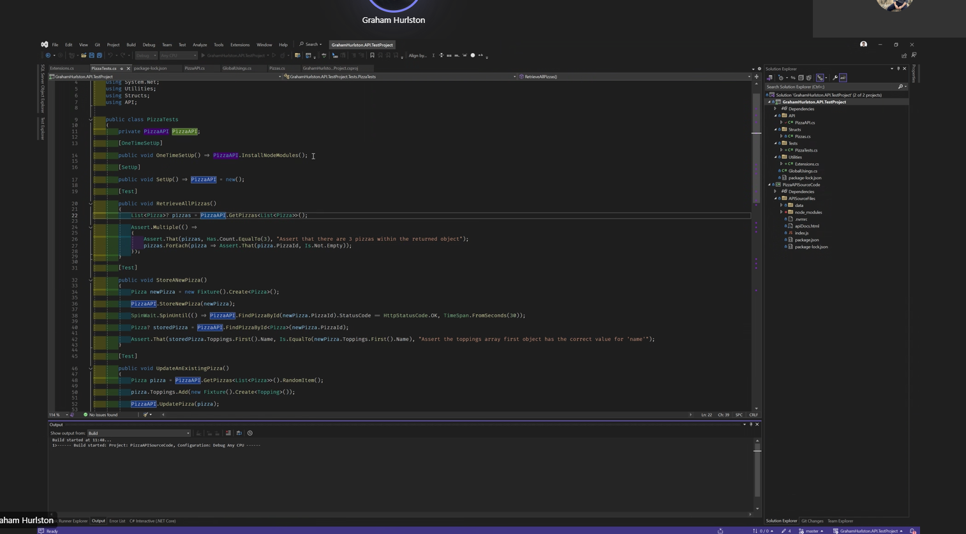
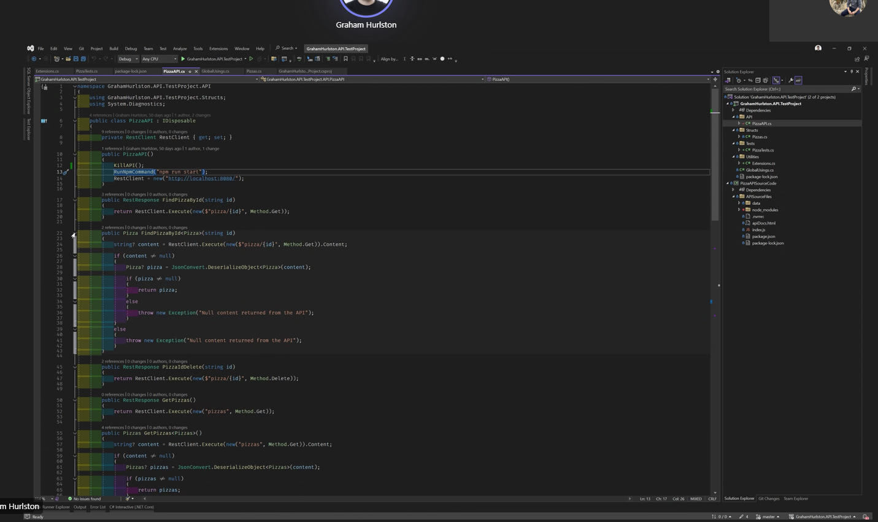
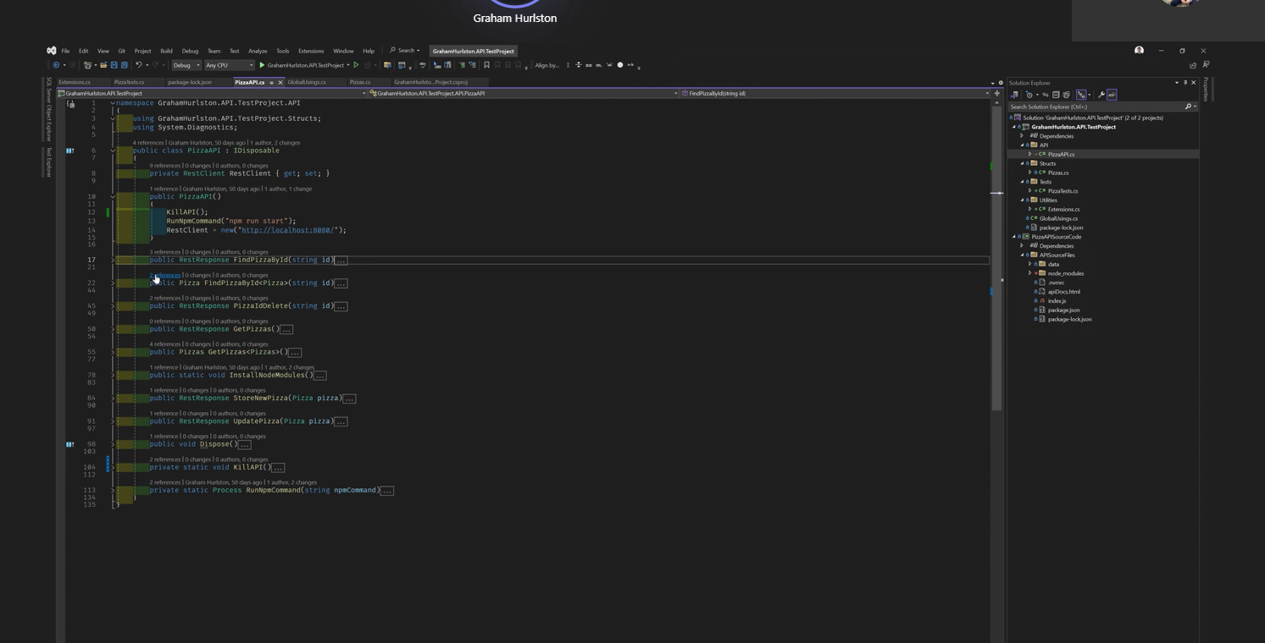
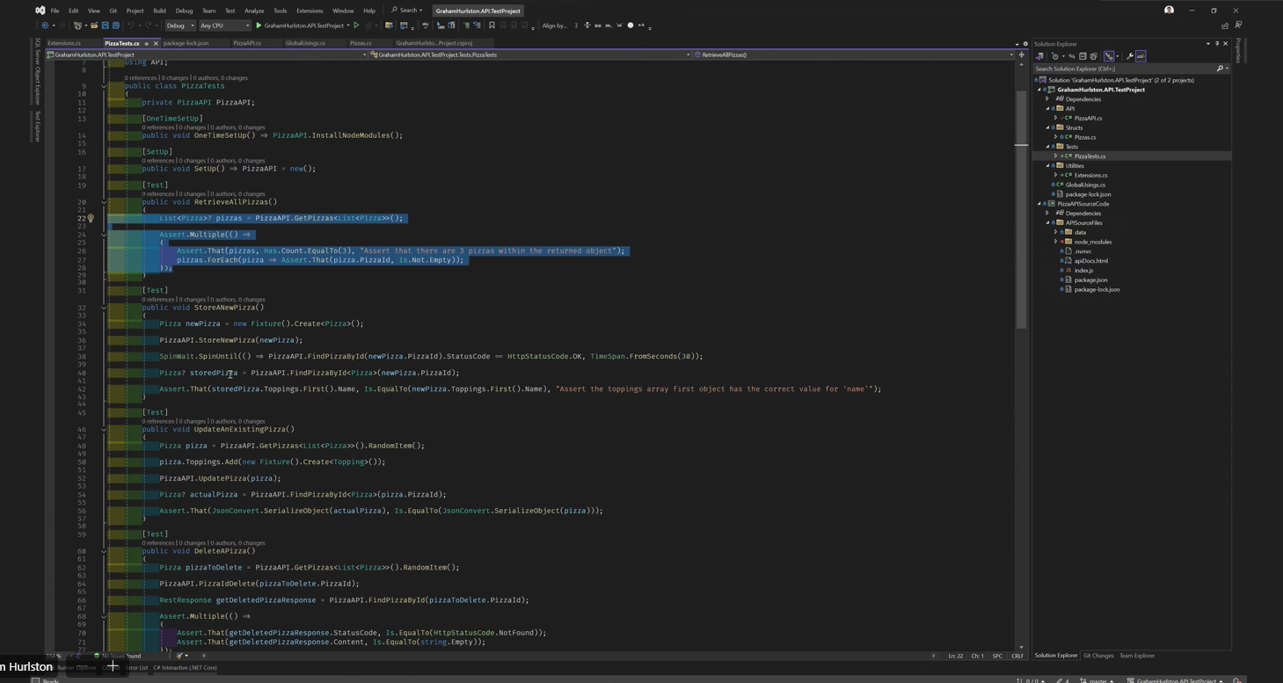
Auto fixture –
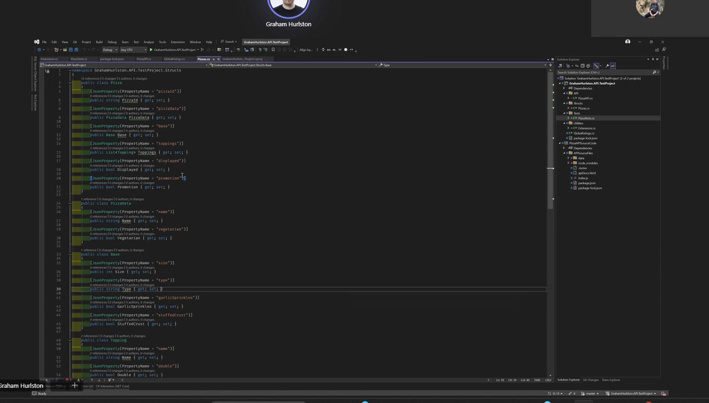
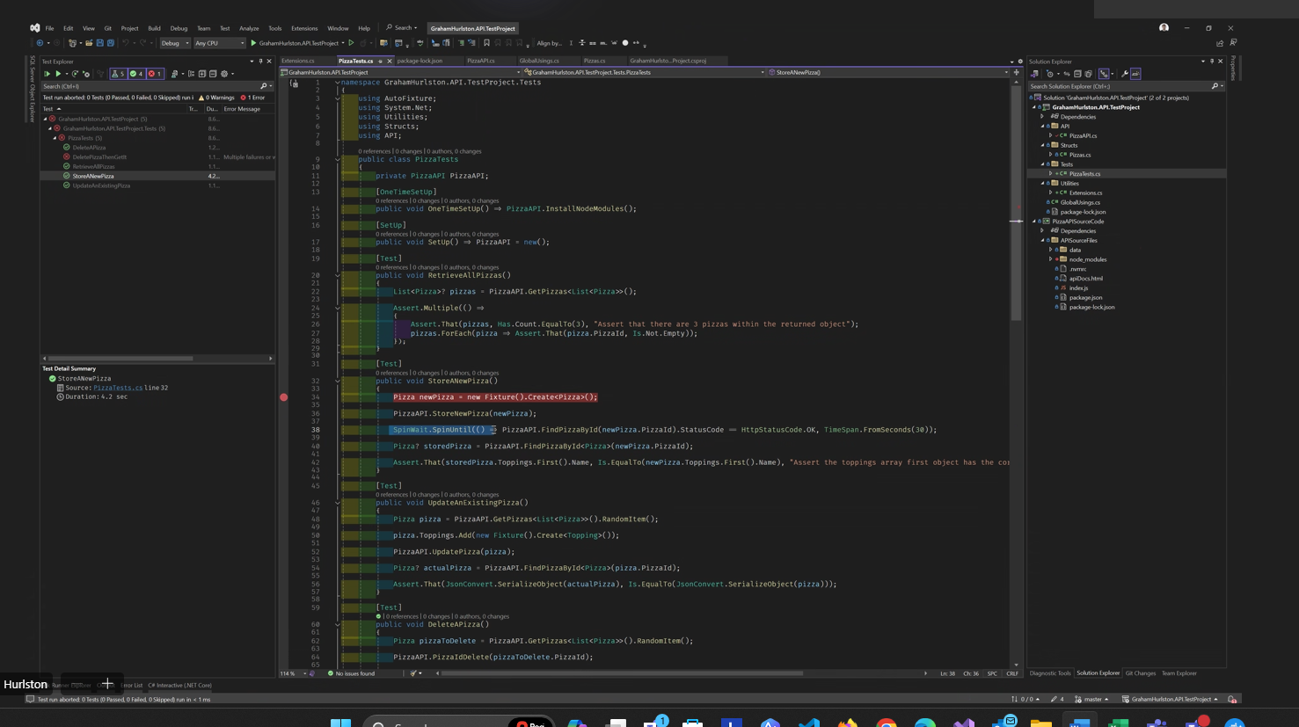
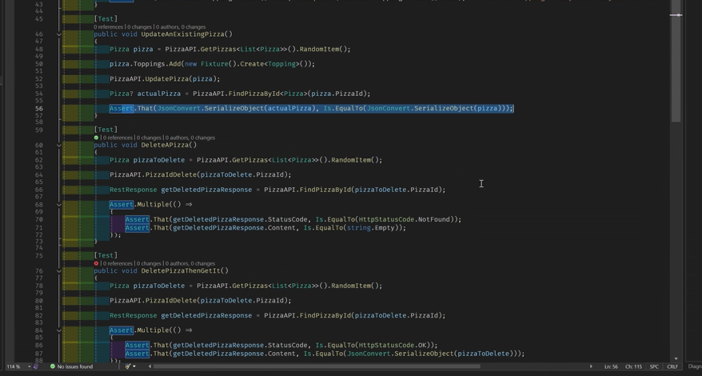
Neated up – API

Desktop – spin wait – return Boolean – changed
Line 21 – done
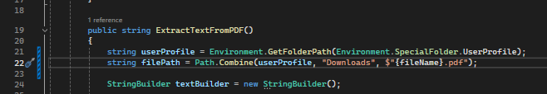
Environment.username for file path
File path

Maintenance
Random object – new random –
Moving to pages class HOME
